Paired Code Review Record (Blank Template)

TechSolutions Intranet – Maintenance Log Feature

1. Review Details
Author: Kian O’Meara
Reviewer: Olly Powell
Date: 29/01/2026
Files / Components Reviewed:
index.html
Version / Commit (if used): Final

2. Review Objective
(What requirement, KPI, or acceptance criterion is this review checking?)
Check whether the html code meets requirements to save complete, accurate records with clear validation/error messages and robust handling of invalid inputs, aligned to KPIs:
- ≥90% entries completed without correction on first attempt
- Clear messages enabling self-recovery without support
- No missing mandatory fields on save

3. Start and End Conditions
Start Condition:
Reviewer has access to the repo and html file

End Condition:
Review checklist completed, findings evidenced, and a prioritised change list produced and shared with the author.

4. Findings Checklist

A. Functionality & Logic
(Errors, incorrect outcomes, missing logic, unexpected behaviour)
- All the HTML code looks correct and is all in order and runs correctly pushing out the correct output

Evidence (line numbers / screenshot):

B. Code Organisation
(Naming, structure, readability, comments)
- Needs more comments
- Naming is all clear
Evidence:
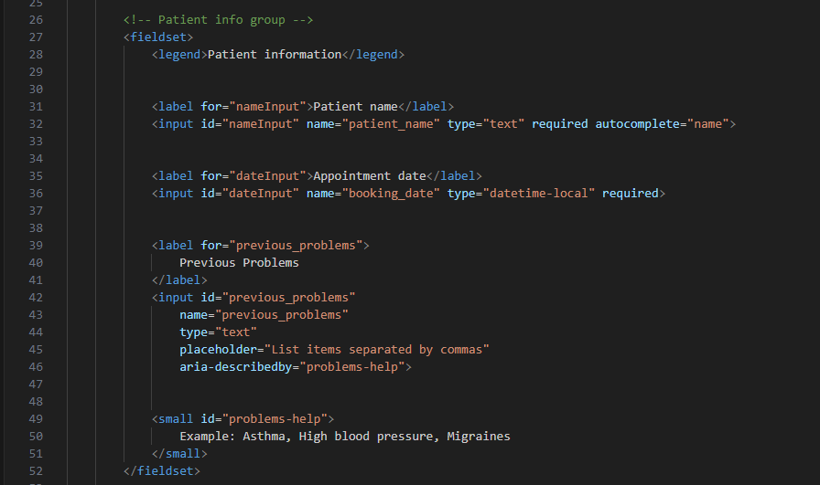

C. Validation & Error Handling
(Missing validation, unclear messages, poor handling of edge cases)
- Needs more information on the missing pieces in the boxes on the form
Evidence:
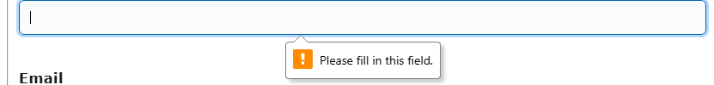

D. Efficiency
(Repeated code, unnecessary complexity, performance concerns)
- The code is efficient and no unnecessary complexities

Evidence: __________________________________________

E. Data Handling & Security
(Incorrect database operations, unsafe input handling, potential leaks)
- No issues with any of the handling or data security

Evidence: __________________________________________

F. Standards, Accessibility & Legal Considerations
(Clarity of system messages, compliance with accessibility expectations, safe handling of information)
- All of the form is accessible, compliant to the accessibility expectations
- handles information safely
Evidence: __________________________________________

G. Testing & Edge Case Coverage
(Missing tests, untested conditions, failing behaviours)
- No issues with the testing and edge case coverage

Evidence: __________________________________________

5. Prioritised Improvements

Issue Identified | Proposed Fix | Priority (P1 / P2 / P3) | Linked Requirement/KPI
Missing comments | Add more comments throughout the code | P2 | The code is clear and easy to follow along
Error messages need to be clearer | Add more detail to the error messages so people easily understand what is missing | P2 | The forms error messages are clear and easy to understand

6. Reviewer Summary (Short)
(Top 3 issues + impact on the system)
- Missing comments, has no impact but would be helpful for if the code needs tweaking in the future
- Error message clarity, they need to clearer so people know what to fill in straight away

Overall Summary:
The HTML is good and is all set out correctly, no unnecessary sections just needs comments and error messages need to be clearer

7. Author Response (Optional)
(Accept / Decline each suggestion + rationale)
I accept all of the suggestions as they are valid and give clear ideas on what is wrong, and I shall implement them into my code to make the website better and more streamlined for potential users

